**PROJECT 3 : Deploying a website on linux ec2 instance and configuring an Application ELB to distribute the traffic between two ec2 instances**

**Webserver1 EC2 Instance Details :**

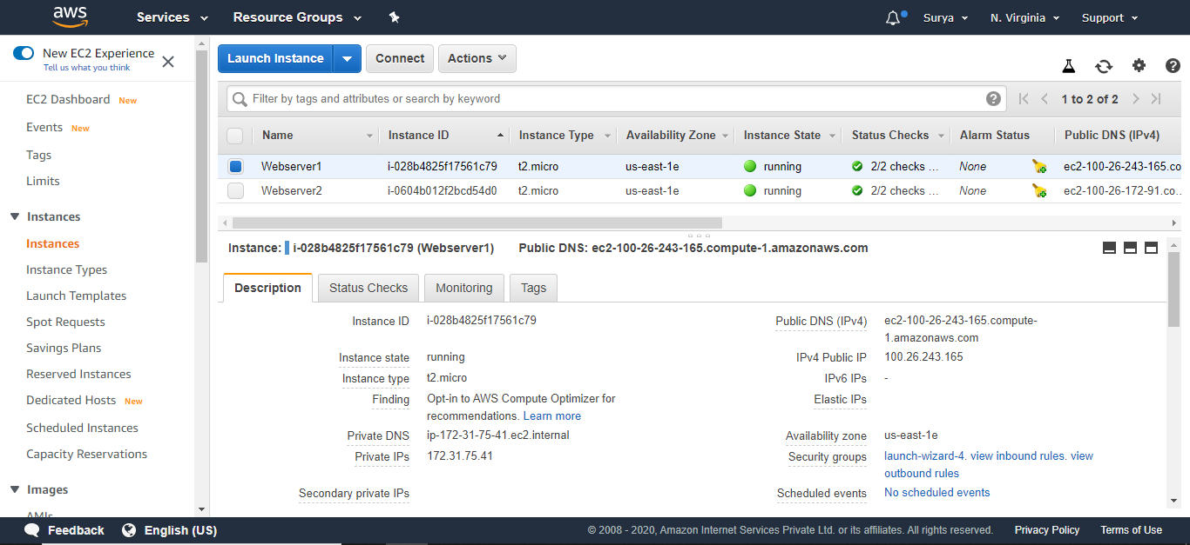

**Webserver2 EC2 Instance Details :**

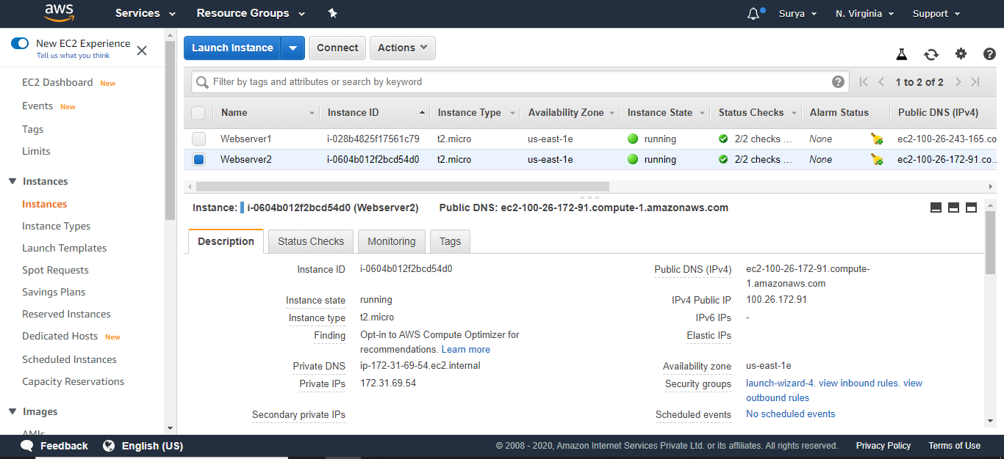

**Sample Web Application deployed on Apache Web Server in Webserver1 EC2 instance :**

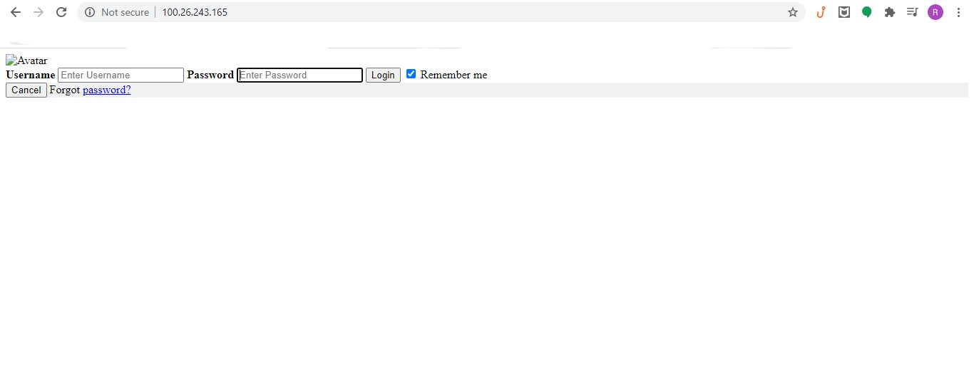

**Sample Web Application deployed on Apache Web Server in Webserver2 EC2 instance :**

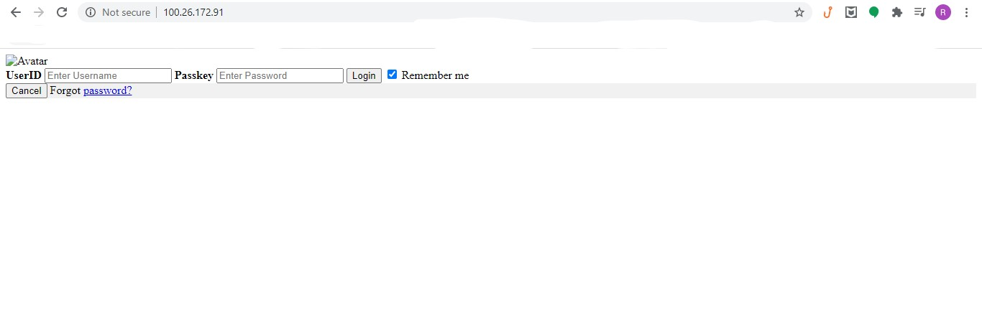

**Application ELB Details :**

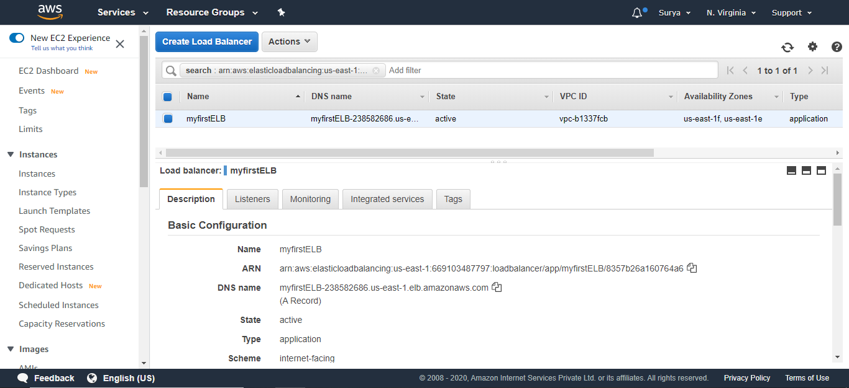

**Accessing Sample Web Application Page in Webserver1 via ELB :**

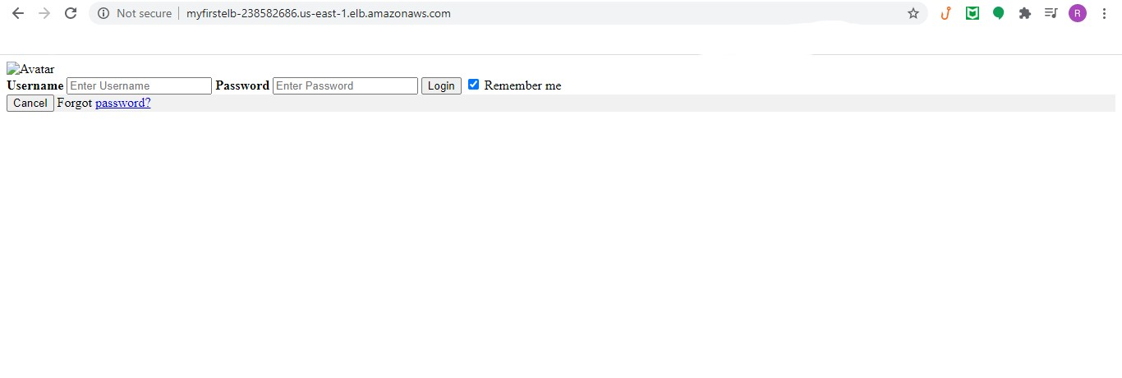

**Accessing Sample Web Application Page in Webserver2 via ELB :**

